Chapter 17, Problem 56.

The Fourier series trigonometric representation of a periodic function is

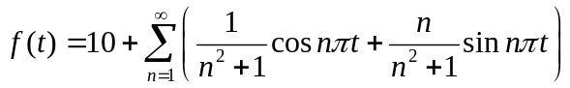

Find the exponential Fourier series representation of f(t).

